'''
ASTHA PRIYA
CS - A
20219024
1. TCP Client-Server Program
CLIENT
'''

import socket

s = socket.socket()
port = 12456
s.connect(('192.168.10.129',port))
print(f"Recieved From SERVER: {s.recv(1024).decode()}")
s.close()

'''
OUTPUT:
Recieved From SERVER: hi, this is astha
'''
'''
ASTHA PRIYA
CS - A
20219024
1. TCP Client-Server Program
Server
'''

import socket

port = 12456

s = socket.socket()
s.bind(('192.168.10.129', port))
s.listen(5)

print("TCP Server is running...")

while True:
c, addr = s.accept()
msg = input("Message to client: ")
c.send(msg.encode())
c.close()
break

'''
OUTPUT:
TCP Server is running...
Message to client: hi, this is astha
'''
'''
ASTHA PRIYA
CS - A
20219024
2. UDP Client-Server Program
Client
'''

import socket

localip = "127.0.0.1"
port = 12367

c = socket.socket(family=socket.AF_INET, type=socket.SOCK_DGRAM)

msg = input("CLIENT: ")
c.sendto(str.encode(msg), (localip, port))

msgaddrpair = c.recvfrom(1024)
msg = msgaddrpair[0]
print(f"SERVER: {msg.decode()}")

'''
OUTPUT:

CLIENT: hi, this is your message
SERVER: hello, i received
'''
'''
ASTHA PRIYA
CS - A
20219024
2. UDP Client-Server Program
Server
'''

import socket

port = 12367
localip = "127.0.0.1"

s = socket.socket(family = socket.AF_INET, type = socket.SOCK_DGRAM)
s.bind((localip,port))
print("UDP Server running...")

while True:
msgaddrpair = s.recvfrom(1024)
msgclient = msgaddrpair[0]
address = msgaddrpair[1]

print("CLIENT: {}".format(msgclient.decode()))

msg = input("SERVER: ")
s.sendto(msg.encode(),address)

'''
OUTPUT:

UDP Server running...
CLIENT: hi, this is your message
SERVER: hello, i received
'''
'''
ASTHA PRIYA
CS - A
20219024
3. Single Chat
Client
'''

import socket
s = socket.socket(socket.AF_INET,socket.SOCK_STREAM)
LOCALHOST = '127.0.0.1'
port = 9990

s.connect((LOCALHOST,port))
print("New client created:")

while True:
client_message = input("Me: ")
s.send(client_message.encode())

msg_received = s.recv(1024)
msg_received = msg_received.decode()
print("Server:",msg_received)

if msg_received == 'exit':
break;
s.close()

'''
OUTPUT:

New client created:
Me: hi
Server: hello
Me: this is a msg
Server: i received your msg
Me: waiting for answer
Server: ??
'''
'''
ASTHA PRIYA
CS - A
20219024
3. Single Chat
Server
'''

import socket
server_socket = socket.socket(socket.AF_INET,socket.SOCK_STREAM)
LOCALHOST = '127.0.0.1'
port = 9990

server_socket.bind((LOCALHOST,port))
server_socket.listen(5)

print("Server started...")

client_sockets,addr=server_socket.accept()
while True:
msg_received = client_sockets.recv(1024)
msg_received = msg_received.decode()
print("Client:", msg_received)

msg_send = input("Me:")
client_sockets.send(msg_send.encode("ascii"))

client_sockets.close()

'''
OUTPUT:

Server started...
Client: hi
Me:hello
Client: this is a msg
Me:i received your msg
Client: waiting for answer
Me:??
'''
'''
ASTHA PRIYA
CS - A
20219024
4.. Multi Chat
'''

import socket
import select
import sys

server = socket.socket(socket.AF_INET, socket.SOCK_STREAM)
if len(sys.argv) != 2:
print ("Correct usage: script, name")
exit()
IP_address = "192.168.10.129"
Port = 5050
name = str(sys.argv[1]).encode()
server.connect((IP_address, Port))

server.send(name)

while True:
sockets_list = [sys.stdin, server]
read_sockets,write_socket, error_socket = select.select(sockets_list,[],[])
for socks in read_sockets:
if socks == server:
message = socks.recv(2048)
print (message.decode())
else:
message = sys.stdin.readline()
server.send(message.encode())
sys.stdout.write("<You>")
sys.stdout.write(message)
sys.stdout.flush()
server.close()

'''
OUTPUT:

Welcome to this chatroom!
<riya> hi

hello
<You>hello
'''
'''
ASTHA PRIYA
CS - A
20219024
4. Multi Chat
'''

from _thread import *
import socket, sys

server = socket.socket(socket.AF_INET, socket.SOCK_STREAM)
server.setsockopt(socket.SOL_SOCKET, socket.SO_REUSEADDR, 1)

IP = "192.168.10.129"
PORT = 5050

server.bind((IP, PORT))

name_map = {}

server.listen(100)

list_of_clients = []

def clientthread(conn, addr):
conn.send("Welcome to this chatroom!".encode())
while True:
try:
message = conn.recv(2048)
if message:
print ("<" + name_map[addr[0]] + "> " + str(message.decode()))
message_to_send = "<" + name_map[addr[0]] + "> " + str(message.decode())
broadcast(message_to_send, conn)
else:
remove(conn)
except Exception as e:
print(e)
continue

def broadcast(message, connection):
for clients in list_of_clients:
if clients!=connection:
try:
clients.send(message.encode())
except:
clients.close()
remove(clients)

def remove(connection):
if connection in list_of_clients:
list_of_clients.remove(connection)

while True:
conn, addr = server.accept()
name = conn.recv(2048).decode()
name_map[addr[0]] = name
list_of_clients.append(conn)
print (name_map[addr[0]] + " connected")
start_new_thread(clientthread,(conn,addr))

conn.close()
server.close()

'''
OUTPUT:

astha connected
shru connected
riya connected
<riya> hi

<astha> hello

<shru> hey
'''
'''
ASTHA PRIYA
CS - A
20219024
5. CRC Client
'''

import socket

def xor(a, b):

result = []

for i in range(1, len(b)):
if a[i] == b[i]:
result.append('0')
else:
result.append('1')

return ''.join(result)

def mod2div(divident, divisor):

pick = len(divisor)
tmp = divident[0 : pick]

while pick < len(divident):

if tmp[0] == '1':

tmp = xor(divisor, tmp) + divident[pick]

else: tmp = xor('0'*pick, tmp) + divident[pick]

pick += 1

if tmp[0] == '1':
tmp = xor(divisor, tmp)
else:
tmp = xor('0'*pick, tmp)

checkword = tmp
return checkword

def encodeData(data, key):

l_key = len(key)

appended_data = data + '0'*(l_key-1)
remainder = mod2div(appended_data, key)

codeword = data + remainder
return codeword

s = socket.socket()

port = 12345

s.connect(('127.0.0.1', port))

input_string = input("Enter data you want to send->")
data =(''.join(format(ord(x), 'b') for x in input_string))
print("Entered data in binary format :",data)
key = "1001"

ans = encodeData(data,key)
print("Encoded data to be sent to server in binary format :",ans)
s.sendto(ans.encode(),('127.0.0.1', 12345))

print("Received feedback from server :",s.recv(1024).decode())

s.close()

'''
OUTPUT:

Enter data you want to send->asdfghbvc
Entered data in binary format : 110000111100111100100110011011001111101000110001011101101100011
Encoded data to be sent to server in binary format : 110000111100111100100110011011001111101000110001011101101100011100
Received feedback from server : THANK you
Data ->110000111100111100100110011011001111101000110001011101101100011100 Received No error FOUND
'''
'''
ASTHA PRIYA
CS - A
20219024
5. CRC SERVER
'''

import socket

def xor(a, b):

result = []

for i in range(1, len(b)):
if a[i] == b[i]:
result.append('0')
else:
result.append('1')

return ''.join(result)

def mod2div(divident, divisor):

pick = len(divisor)
tmp = divident[0:pick]

while pick < len(divident):

if tmp[0] == '1':

tmp = xor(divisor, tmp) + divident[pick]

else:
tmp = xor('0'*pick, tmp) + divident[pick]

pick += 1

if tmp[0] == '1':
tmp = xor(divisor, tmp)
else:
tmp = xor('0'*pick, tmp)

checkword = tmp
return checkword

def decodeData(data, key):

l_key = len(key)

appended_data = data.decode() + '0'*(l_key-1)
remainder = mod2div(appended_data, key)

return remainder

s = socket.socket()
print("Socket successfully created")

port = 12345

s.bind(('', port))
print("socket binded to %s" % (port))
s.listen(5)
print("socket is listening")

while True:
c, addr = s.accept()
print('Got connection from', addr)

data = c.recv(1024)

print("Received encoded data in binary format :", data.decode())

if not data:
break

key = "1001"

ans = decodeData(data, key)
print("Remainder after decoding is->"+ans)

temp = "0" * (len(key) - 1)
if ans == temp:
c.sendto(("THANK you Data ->"+data.decode() +
" Received No error FOUND").encode(), ('127.0.0.1', 12345))
else:
c.sendto(("Error in data").encode(), ('127.0.0.1', 12345))

c.close()

'''
OUTPUT:

Socket successfully created
socket binded to 12345
socket is listening
Got connection from ('127.0.0.1', 50344)
Received encoded data in binary format : 110000111100111100100110011011001111101000110001011101101100011100
Remainder after decoding is->000
'''
'''
ASTHA PRIYA
CS - A
20219024
6. HAMMING CODE CLIENT
'''

# Import socket module
import socket

def calcRedundantBits(m):

for i in range(m):
if(2**i >= m + i + 1):
return i

def posRedundantBits(data, r):

j = 0
k = 1
m = len(data)
res = ''

for i in range(1, m + r+1):
if(i == 2**j):
res = res + '0'
j += 1
else:
res = res + data[-1 * k]
k += 1

return res[::-1]

def calcParityBits(arr, r):
n = len(arr)
for i in range(r):
val = 0
for j in range(1, n + 1):

if(j & (2**i) == (2**i)):
val = val ^ int(arr[-1 * j])

arr = arr[:n-(2**i)] + str(val) + arr[n-(2**i)+1:]
return arr

s = socket.socket()

# Define the port on which you want to connect
port = 12345

# connect to the server on local computer
s.connect(('127.0.0.1', port))

data = str(input("Enter the data in binary : "))

m = len(data)
r = calcRedundantBits(m)

arr = posRedundantBits(data, r)

arr = calcParityBits(arr, r)

print("Data sent to server :",arr)
s.sendto(arr.encode(),('127.0.0.1', 12345))

# receive data from the server
print("Received feedback from server :",s.recv(1024).decode())

# close the connection
s.close()

'''
$ python3 client.py
Enter the data in binary : 01010011
Data sent to server : 010100011100
Received feedback from server : The position of error is 2 from the left
'''
'''
ASTHA PRIYA
CS - A
20219024
6. HAMMMING CODE SERVER
'''

# First of all import the socket library
import socket

def detectError(arr, nr):
n = len(arr)
res = 0

for i in range(nr):
val = 0
for j in range(1, n + 1):
if(j & (2**i) == (2**i)):
val = val ^ int(arr[-1 * j])

res = res + val*(10**i)

return int(str(res), 2)
def calcRedundantBits(m):

for i in range(m):
if(2**i >= m + i + 1):
return i
s = socket.socket()
print("Socket successfully created")

# reserve a port on your computer in our
# case it is 12345 but it can be anything
port = 12345

s.bind(('', port))
print("socket binded to %s" % (port))
# put the socket into listening mode
s.listen(5)
print("socket is listening")

while True:
# Establish connection with client.
c, addr = s.accept()
print('Got connection from', addr)

# Get data from client
data = c.recv(1024)

print("Received data :", data.decode())

if not data:
break

arr = '11101001110'
m = len(data)
r = calcRedundantBits(m)
print("Error Data is " + arr)
correction = detectError(arr, r)
if(correction==0):
c.sendto(("No errors found in data :)").encode(), ('127.0.0.1', 12345))
else:
temp=len(arr)-correction+1
st="The position of error is "+str(temp)
st=st+" from the left"
c.sendto((st).encode(), ('127.0.0.1', 12345))

c.close()

'''
$ python3 server.py
Socket successfully created
socket binded to 12345
socket is listening
Got connection from ('127.0.0.1', 38474)
Received data : 010100011100
Error Data is 11101001110
'''
'''
ASTHA PRIYA
CS - A
20219024
7. TRANSPOSITION CIPHER CLIENT
'''

#Client Side
#Columner Transposition Cipher

import socket
import math

HOST='127.0.0.1'
PORT=12347

key = "HACK"
def encryptMessage(msg):
cipher = ""

k_indx = 0

msg_len = float(len(msg))
msg_lst = list(msg)
key_lst = sorted(list(key))

col = len(key)

row = int(math.ceil(msg_len / col))

fill_null = int((row * col) - msg_len)
msg_lst.extend('_' * fill_null)

matrix = [msg_lst[i: i + col]
for i in range(0, len(msg_lst), col)]

for _ in range(col):
curr_idx = key.index(key_lst[k_indx])
cipher += ''.join([row[curr_idx]
for row in matrix])
k_indx += 1

return cipher

def main():
sockett=socket.socket(socket.AF_INET,socket.SOCK_STREAM)
sockett.connect((HOST,PORT))

while True:
msg=input("Enter the plaintext : ")
msg1=msg

postencoding=encryptMessage(msg)
print("Ciphertext generated is : ",postencoding)
msg=postencoding.encode("utf-8")
sockett.send(msg)
print("Message Sent!")

if __name__ == '__main__':
main()

'''
$ python3 client.py
Enter the plaintext : hi! this is astha
Ciphertext generated is : ihis_!ist_ht aa s h_
Message Sent!
'''
'''
ASTHA PRIYA
CS - A
20219024
7. TRANSPOSITION CIPHER SERVER
'''

#Server Side
#Columner Transposition Cipher

import socket
import math

key = "HACK"
IP = '127.0.0.1'
PORT = 12347

def decryptMessage(cipher):
msg = ""

# track key indices
k_indx = 0

# track msg indices
msg_indx = 0
msg_len = float(len(cipher))
msg_lst = list(cipher)

col = len(key)

row = int(math.ceil(msg_len / col))

key_lst = sorted(list(key))

dec_cipher = []
for _ in range(row):
dec_cipher += [[None] * col]

for _ in range(col):
curr_idx = key.index(key_lst[k_indx])

for j in range(row):
dec_cipher[j][curr_idx] = msg_lst[msg_indx]
msg_indx += 1
k_indx += 1

try:
msg = ''.join(sum(dec_cipher, []))
except TypeError:
raise TypeError("This program cannot",
"handle repeating words.")

null_count = msg.count('_')

if null_count > 0:
return msg[: -null_count]

return msg

def main():
server = socket.socket(socket.AF_INET, socket.SOCK_STREAM)
server.bind((IP, PORT))
server.listen(10)
while True:
client, address = server.accept()
print(f"Connected to {address[0]} :{address[1]}")
ds=client.recv(1024).decode("utf-8")
print("Data received is {}".format(ds))

postdecoding=decryptMessage(ds)
print("Plaintext after decoding is : ",postdecoding)

if __name__ == '__main__':
main()

'''
$ python3 server.py
Connected to 127.0.0.1 :44574
Data received is ihis_!ist_ht aa s h_
Plaintext after decoding is : hi! this is astha
'''
'''
ASTHA PRIYA
CS - A
20219024
8. SUBSTITUTION CIPHER DECRYPTION
'''

import socket

def decode(cipher,key):
lkey = len(key)
ltext = len(cipher)
plain = ''
alphabets = 'abcdefghijklmnopqrstuvwxyz'
c=0
while(c<ltext):
ch = cipher[c]
d = 0
while(d<len(alphabets)):
if alphabets[d] == ch:
break
d+=1
if(d>lkey-1):
d-=lkey
else:
d+=(len(alphabets)-lkey)

plain+=alphabets[d]
c+=1
return plain

port = 12345
localip = '127.0.0.1'
s = socket.socket()

s.connect((localip,port))
dat = s.recv(1024).decode()
d = dat.split(' ')
cipher = d[0]
key = d[1]

print("Ciphertext: ", cipher)
plain = decode(cipher,key)
print("PlainText: ", plain)

'''
$ python3 sub_de.py
Ciphertext: cuvjc
PlainText: astha
'''
'''
ASTHA PRIYA
CS - A
20219024
8. SUBSTITUTION CIPHER ENCRYPTION
'''

import socket

def encode(plain,key):
lkey = len(key)
ltext = len(plain)
cipher = ''
alphabets = 'abcdefghijklmnopqrstuvwxyz'
c=0
while(c<ltext):
ch = plain[c]
d = 0
while(d<len(alphabets)):
if alphabets[d] == ch:
break
d+=1
if(d<len(alphabets)-lkey):
d+=lkey
else:
d-=(len(alphabets)-lkey)

cipher+=alphabets[d]
c+=1
return cipher
s = socket.socket()
print ("Socket Successfully connected")

port = 12345
localip = '127.0.0.1'
s.bind(('',port))
print("socket binded to port ",port)

s.listen(5)
print("Socket is listeing")

c,addr = s.accept()
print("Connection from ", addr)

plain = input("Enter the message: ")
key = input("Enter the key: ")

cipher = encode(plain,key)
print("CipherText: ", cipher)
finaldat = cipher + ' ' + key
c.sendto((finaldat).encode(),(localip,port))

c.close()

'''
$ python3 sub_en.py
Socket Successfully connected
socket binded to port 12345
Socket is listeing
Connection from ('127.0.0.1', 60884)
Enter the message: astha
Enter the key: qw
CipherText: cuvjc
'''

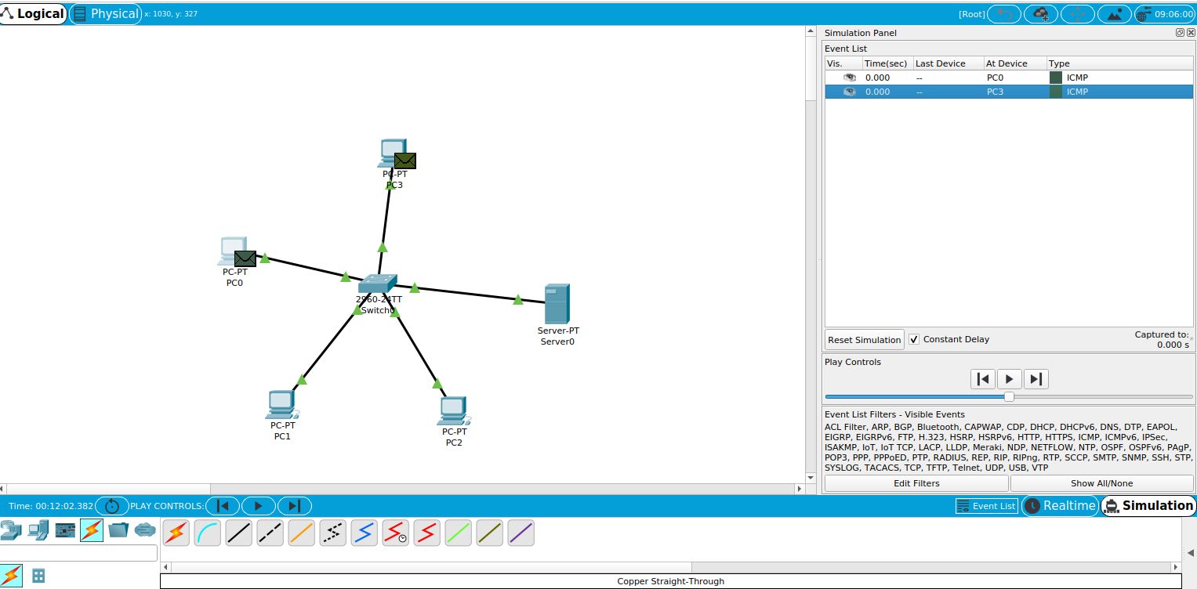
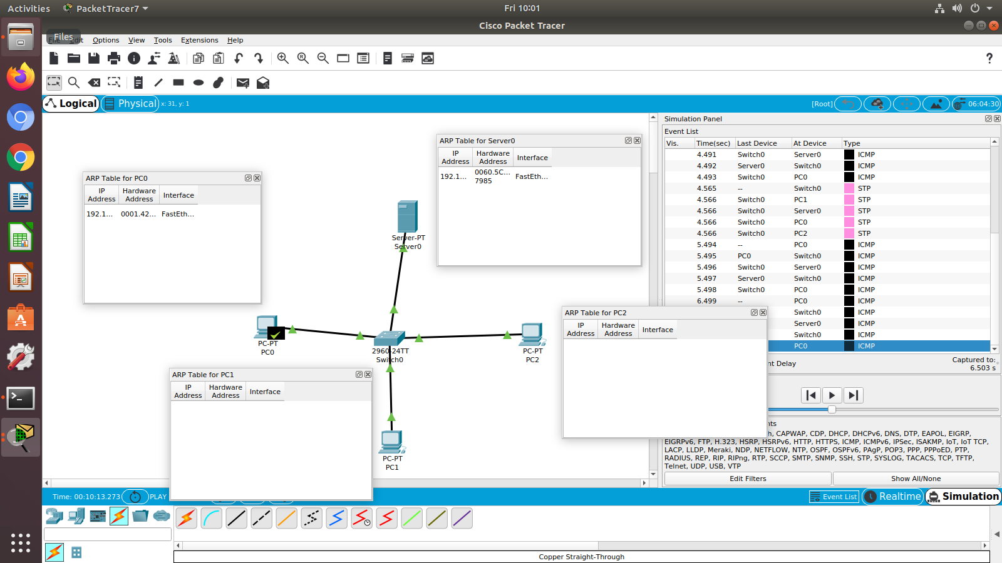
'''
ASTHA PRIYA
CS - A
20219024
11. LZW Compression
'''

def encode(string):
table = dict()
lis = []
for i in range(256):
table[chr(i)] = i
current = ''
nxt_code = 257
for i in string:
current+=i
if(current not in table):
table[current] = nxt_code
nxt_code += 1
current = current[:-1]
lis.append(table[current])
current = i
lis.append(table[current])
return lis

def decode(lis):
table = dict()
for i in range(256):
table[i] = chr(i)
prev = ''
nxt_code = 257
ans = ''
for i in lis:
ans+=table[i]
if(prev != ''):
table[nxt_code] = prev+table[i][0]
nxt_code+=1
prev = table[i]
return ans

def main():
lis = []
msg = input("ENTER THE MESSAGE: ")
lis = encode(msg)
print("AFTER COMPRESSION: ",lis)
ans = decode(lis)
print("AFTER DECOMPRESSION: ",ans)

if __name__ == '__main__':
main()

'''
OUTPUT:
ENTER THE MESSAGE: Hello
AFTER COMPRESSION: [72,101,108,108,111]
AFTER DECOMPRESSION: Hello
'''

